Adventurer’s Guide
Download press assets here: https://perfectworld.box.com/v/NeverwinterAdventurersGuide

Introduction to Neverwinter

Neverwinter is a sprawling, free-to-play, fantasy MMORPG based on the popular tabletop roleplaying game, Dungeons & Dragons. The game is set in the city of Neverwinter--one of the most beloved locations from The Forgotten Realms campaign--as it rises from the ashes of destruction.

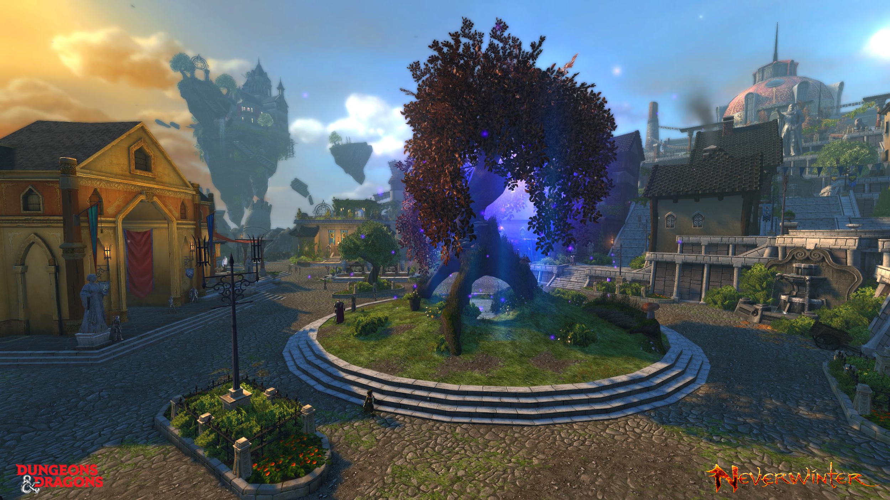
The City of Neverwinter

With the city of Neverwinter as your stronghold, you will adventure forth into the mysterious lands of The Forgotten Realms, where you will discover plenty of unique locations and an array of terrifying enemies. One moment you’ll be on the eerie, moonlit streets of Ravenloft, trying to survive the night as a host of werewolves and vampires descend upon you. The next you could be in the magical forests of Sharandar--painted with an iridescent palette of purples and blues--helping the proud elves retake their homeland from an army of evil Fey creatures. Or, in true Dungeons & Dragons fashion, you could descend into the underground labyrinth of Underdark, where, if the Mind Flayers don’t get you first, the plants surely will.

To help you and fellow adventurers to easily find the information in this guide, here’s a table of contents with bookmarks to take you to each section!

Table of Contents

Race & Class Overview - Creating an Epic Adventurer
  - Races
  - Classes
    - New Bard Class Overview
    - Neverwinter Development Team’s Favorite Classes to Play

10 Tips New Players Need to Know

How Does the New Leveling System Work?

Endgame Content Overview - Explore & Experience The Vast World of Neverwinter

Races & Classes Overview - Creating an Epic Adventurer

How you approach the many challenges in Neverwinter, how you look doing it, and the epic adventurer you’d like to be is completely up to you.

Races
At the start of your journey, you’ll be able to choose from 12 distinct races, with each race having their own unique racial traits (passive bonuses). Some of the races are more standard for those familiar with fantasy games, like humans, elves, and dwarves, but there are also some unique races to Neverwinter, such as the Dragonborn and goblin-like Gith.

- Drow: A decadent race of dark elves whose beauty and sophistication fail to mask hearts all too often stained in evil.
- Dwarf: Short and stout people claiming to have been hewn from the underground rock they call home. Strong, hardy, and dependable, they have deep respect for their friends, gods, and ancestors.
- Half-Elf: Descended from elves and humans, half-elves are a vital race in which the best features of elves and humans often appear.
- Half-Orc: Half-orcs combine the best qualities of humans and orcs, though some would argue that the good qualities of orcs are few and hard to find. From their orc blood, half-orcs inherit great physical strength and toughness.
- Halfling: Halflings are a small race known for their resourcefulness, quick wits, and steady nerves. They are a nomadic folk who roam waterway and marshlands.
- Human: Of all the civilized races, humans are the most adaptable and diverse. Human settlements can be found almost anywhere, and human morals, customs, and interests vary greatly.
- Menzoberranzan Renegade: Drow from the city of Menzoberranzan are raised in a world of lies and treachery. The noble houses of these dark elves are in constant conflict, vying for power and the favor of their evil goddess, Lolth the Spider Queen.
- Moon Elf: Moon elves revel in travel and exploration. Open to new experiences and honest by nature, moon elves are often seen as worthy companions by the people they meet in their travels.
- Sun Elf: The sun elves have lived apart from the events of the world for thousands of years. They mimic the aloof nature of their society in their personal actions as well.
- Tiefling: Plagued by a dark and sinister heritage, tieflings walk through the shadows of their race's past, savoring the darkness or trying to escape it.
- Dragonborn: Born to fight, Dragonborn are a race of wandering mercenaries, soldiers, and adventurers. Long ago, their empire contended for worldwide dominion, but now only a few rootless clans of their honorable warriors remain to pass on their legends of ancient glory.

Classes
There are 10 core classes in Neverwinter, and which one you choose will heavily affect your gameplay. Here’s a quick breakdown of which class could be a great fit for you:
- For those who prefer to jump straight into a fight, bash enemies and soak up a ton of damage, there’s the Barbarian, Warrior, and Paladin.
- For others with more guile and cunning, who like to keep their enemy at a distance before they deliver a lethal blow, there’s the Rogue and Ranger.
- And of course for those that attune more with spell-casting, whether as a boon for allies or a bane for enemies, there are the Wizard, Warlock, and Cleric classes.

Classes:
- Bard - A versatile adventurer, the bard commands the power of song to be a powerful healer or a stylish combatant. Regardless of their path, it is a bard’s ability to perform that determines how far they can go.
- Barbarian - The barbarian is an unstoppable warrior skilled with heavy weapons. Some barbarians hail from savage lands but all embrace their inner beast to become raging hurricanes on the battlefield. Upon reaching level 11 barbarians may specialize in either dealing damage or tanking.
- Cleric - The cleric draws upon the divinity of their god or goddess to heal wounds and smite foes. The cleric ensures their companions make it through even the most harrowing encounters alive. Upon reaching level 11 clerics may specialize in either healing or dealing damage.
- Fighter - The fighter is a warrior who places themselves in harm's way to protect their allies. Sword in hand and shield held steady, the fighter shrugs off devastating attacks and retaliates with a vengeance. Upon reaching level 11 fighters may specialize in either tanking or dealing damage.
- Paladin - The paladin is a righteous defender of the innocent, a holy knight devoted to the pursuit of justice. The paladin draws upon their faith, wielding divine radiant power (physical power - Strength) to deal damage & healing Magic (Wisdom) to heal self and allies. Upon reaching level 11 paladins may specialize in either tanking or healing.
- Ranger - The ranger is a worldwise wanderer versed in archery and melee combat. Rangers unleash a hail of arrows on foes from afar before closing the gap and finishing them off with close range attacks. Rangers specialize in dealing damage.
- Rogue - The rogue is a master of stealth who strikes from the shadows with deadly precision. Rogues are athletic and nimble fighters who outmaneuver their foes before cutting them down to size. Rogues specialize in dealing damage.
- Warlock - The warlock is a spellcaster who draws power from a pact forged with an eldritch being. Warlocks weave curses and destructive magics and can even drain the life force of their foes. Upon reaching level 11 warlocks may specialize in either dealing damage or healing.
- Wizard - The wizard is a spellcaster whose power is rooted in study of the arcane. To a wizard, knowledge provides the means to summon forth weapons of ice and roiling thunderstorms, or to simply disintegrate enemies with pure arcane power. Wizards specialize in dealing damage.

The Dev Team’s Favorite Classes to Play
If you need a little inspiration to find your path, take a look at the Neverwinter developers’ personal choices below as they share what their favorite classes:
“Ranger is my favorite: If you run, then I shoot at you. If you approach, then I stab at you. It's hard not to like the versatility.” - Robert H., Staff Systems Designer
“My personal favorite is Wizard! I like riding the edge of the glass cannon! Overall wizards are swiss army knives in the D&D universe which makes them so exciting!” - Noah H., Senior Content Designer,
“I like playing Fighters. There's something really satisfying about blocking and being the only one left standing after a huge AoE attack knocks everyone else away. I also get motion sickness pretty easily, so being able to just stand in one place and hit things lets me play longer.” - Amy S., Senior UX Designer

“My favorite class is Rogue, because as with most games that have a rogue class, they are the best DPS. It has high damage with minimal effort and looks cooler than the other classes while doing damage. I’m also pretty sure Duelist Flurry has a higher potency than intended but is resistant to nerfs because of our lead system designer’s denial of how great it is. Being able to go into stealth and pick up things without the need to enter combat with whatever’s guarding it is also cool.” - Steven B., Staff Software Engineer
“Wizard is my pick! Thematically, they've got a lot of cool-looking powers (fireball!). They also have a fun mix of damage (fireball!) and control abilities. Did I mention fireball?” - Randy M., Lead Designer
“I main a Tank Fighter on live. Definitely my favorite class/paragon. If I had to boil it down to one sentence, I guess they have my favorite Tab mechanic. Dig 'in just feels good to do.” - Steven K., Lead Test Analyst
“My favorite class is Bard. For one, I am happy with how it came out visually and it is so well themed.” - Samantha S., Staff VFX Artist
“I was originally a Rogue main, but right now Cleric is my class of choice, on the Arbiter paragon path. I’m primarily a solo player, and I really enjoy the Cleric’s options for burning Divinity to power low-cooldown Encounter powers. The feats provide interesting mechanics for restoring Divinity or providing fun burst windows, and my At-Will powers still get used for rebuilding my meter or prepping for a particularly powerful attack. Plus, I like that I have an option to switch to a healer if I do find myself needing to fill that role in group content … though I definitely need more practice.” - Vincent M, Producer
“Currently, my favorite class is Warlock. I’ve always preferred range DPS over any other style and Warlocks seem less elitist than those fireball-throwing Wizards (We’ll ignore that my alt is a Wizard for the purpose of this reply).” - Julia F., Community Manager

10 Tips New Players Need to Know
1. Know your Non-Player Character (NPC) contact locations – NPCs will be integral in getting you started on your adventures and continuing storylines. At the top of this list is Sgt. Knox, located on the dais of the middle tier of Protector’s Enclave.
2. Explore the Protector’s Enclave – As your initial city hub, Protector’s Enclave (PE) offers various locations for Adventurers in need. From resupplying to resting, take some time to get to know the layout!
3. Experience Special and Seasonal Events – Whether it’s Neverwinter under siege or spooky Masquerade season, various visitor NPCs will populate the large event dais on the ground level of Protector’s Enclave. The NPCs located there will provide the introductory quests for these special events.
4. Pay Last Chance Vendors a Visit – A number of events offer a “Last Chance Vendor”, an NPC vendor that sticks around a week after an event is over so Adventurers can wrap up any unfinished event needs or spend remaining event currency.
5. Set your teleportation hub - Teleportation stones can be found across various adventure zones, including Protector’s Enclave. Interact with one of these stones to set it as your “home” for teleportation!
6. Look for Tales of Lore – Pieces of lore can be found throughout your travels! Make sure to pick up the glittering tomes to add more information to your lore journal and become a loremaster of the Forgotten Realms.
7. Unwind in the Garden – The Protector’s Garden offers a relaxing spot to unwind, visit vendors, and take care of exchanges, invocation, and other tasks. The Garden is available to all during Protector’s Jubilee, but requires a special key to enter after the Anniversary event is over.
8. Manage your inventory overflow – If your inventory bags become too full, additional items will be placed in an overflow slot. Unfortunately, this overflow can be quite encumbering and will limit some of what you can do in game so make sure to spend some time clearing up your bags. Remember you can also place items in the Bank for long-term storage!
9. Know where to find fashion items – Picked up some new fashion items to showcase your style? Locate these items in the Vanity Pet and Fashion tab of your inventory and add them to your Appearance library.
10. Gear up and be ready for battle– Learn more about how gear and stats impact your ability to take on fearsome foes! A good place to start is the Combat Changes Overview video.

How Does the New Leveling System Work?
The leveling system in Neverwinter has been streamlined to allow players to get to the newest content faster while still enjoying the leveling experience and making each level feel rewarding. The new level cap is now 20 and players will achieve new levels at key milestones in the Zones’ stories.
Updates have also been made to the tutorial, allowing players to learn the new system in a more optimal manner. This includes the introduction of the Adventurer’s Guild, the Training Room, and new visuals for important main missions.

Endgame Content Overview - Explore & Experience The Vast World of Neverwinter

You’ll spend most of your early time with the game playing through the extensive storyline; completing that, however, is only just the beginning. Neverwinter has plenty of challenges for players looking to continue their journey and quest for better loot, like Skirmishes, Trials, and our game’s version of raids, Dungeons, which provide the game’s highest level of difficulty. There’s a whole catalogue of existing Dungeons that max level players can already delve into, but each new module also comes with a never-before-seen dungeon. Also worth mentioning is the constant rotation of events, each with their own collection of event-specific gear for you to earn.

